**CS5389 GRAPHICAL USER INTERFACE**

**ASSIGNMENT 1**

**Steps Involved in Execution of the Project:**

**Step1:**

Save the **“Jaya Naga Bhavana Kommuru.cpp”** file in a folder on a LINUX system.

**Step2:**

Go to **“terminal”** and issue the commands as given below in picture.

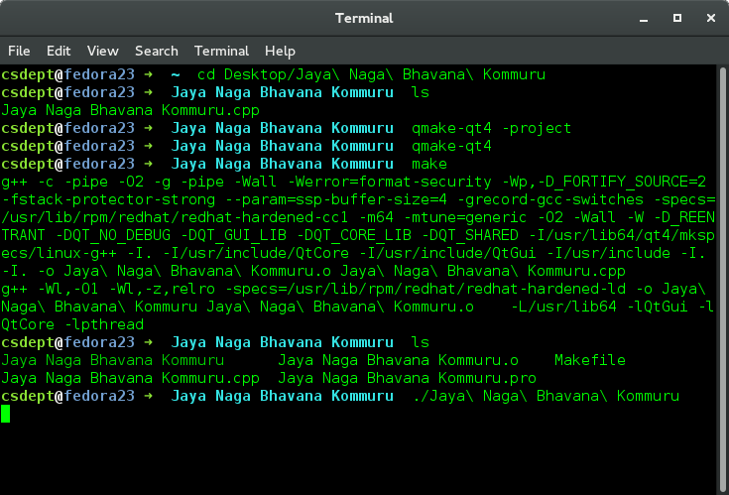

**Step3:**

Once the build is completed,Run the program with a command as follows :

“**./Jaya\Naga\Bhavana\Kommuru”**

This will lead to an output screen as follows:

**ScreenShot1:**

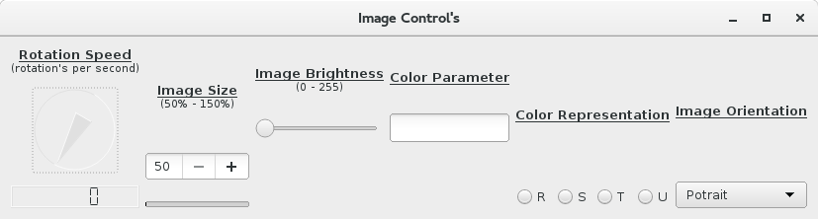

**Step4:**

* If we make any change to the QDial widget it will be displayed on the QLCDNumber widget.
* The QSpinBox widget is connected to QProgressBar widget.Here as the value of spinbox is increased or decreased simultaneously the value of the progressbar changes.
* The QSlider widget is connected to QLabel widget. Here as the value of slider is changed the value is displayed on the label.
* The QLineEdit widget is connected to the QLabel widget.Here as the text in the lineedit is changed by the user simultaneously it is displayed on the label with font color as red.

The output is as below:

**ScreenShot2: (Change of QLCDNumber by adjusting QDail widget)**

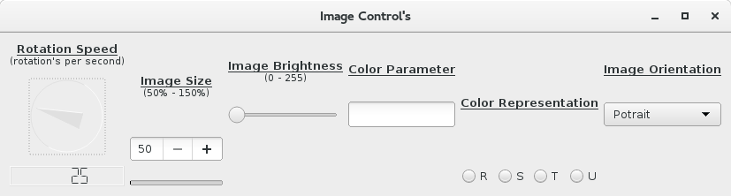

**ScreenShot3: (Change of QProgressBar by adjusting QSpinBox widget)**

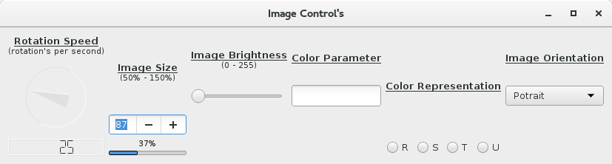

**ScreenShot4: (Change of QLabel by adjusting QHorizontalSlider widget)**

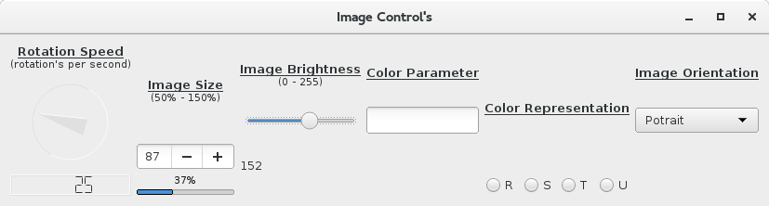

**ScreenShot5: (Change of QLabel by adjusting QLineEdit widget)**

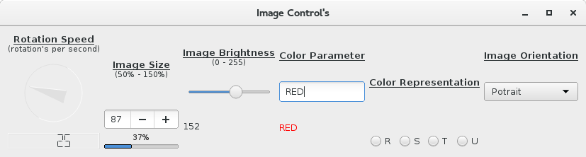

**ScreenShot6: (Change of QLabel by adjusting QRadioButton widget)**

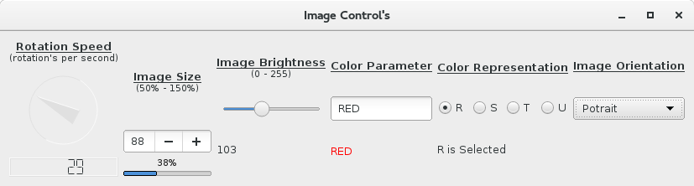

**ScreenShot7: (Change of QLabel by adjusting QComboBox widget)**

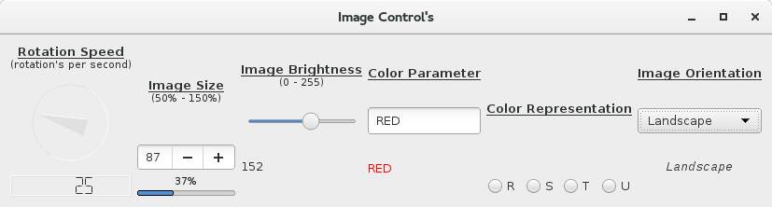

**ScreenShot8: (Main Output)**

